SUPPORTING INFORMATION FOR

The biodiversity we ignore: a global meta-analysis on taxonomic bias

Stefano Mammola, Diego Fontaneto, Adrià Bellvert, Matteo Chialva, Martino Adamo

Table of Contents

- Figure S1. PRISMA diagram of the systematic literature review

- Figure S2. Funnel plot of study-level aggregated effect sizes

- Supporting Literature

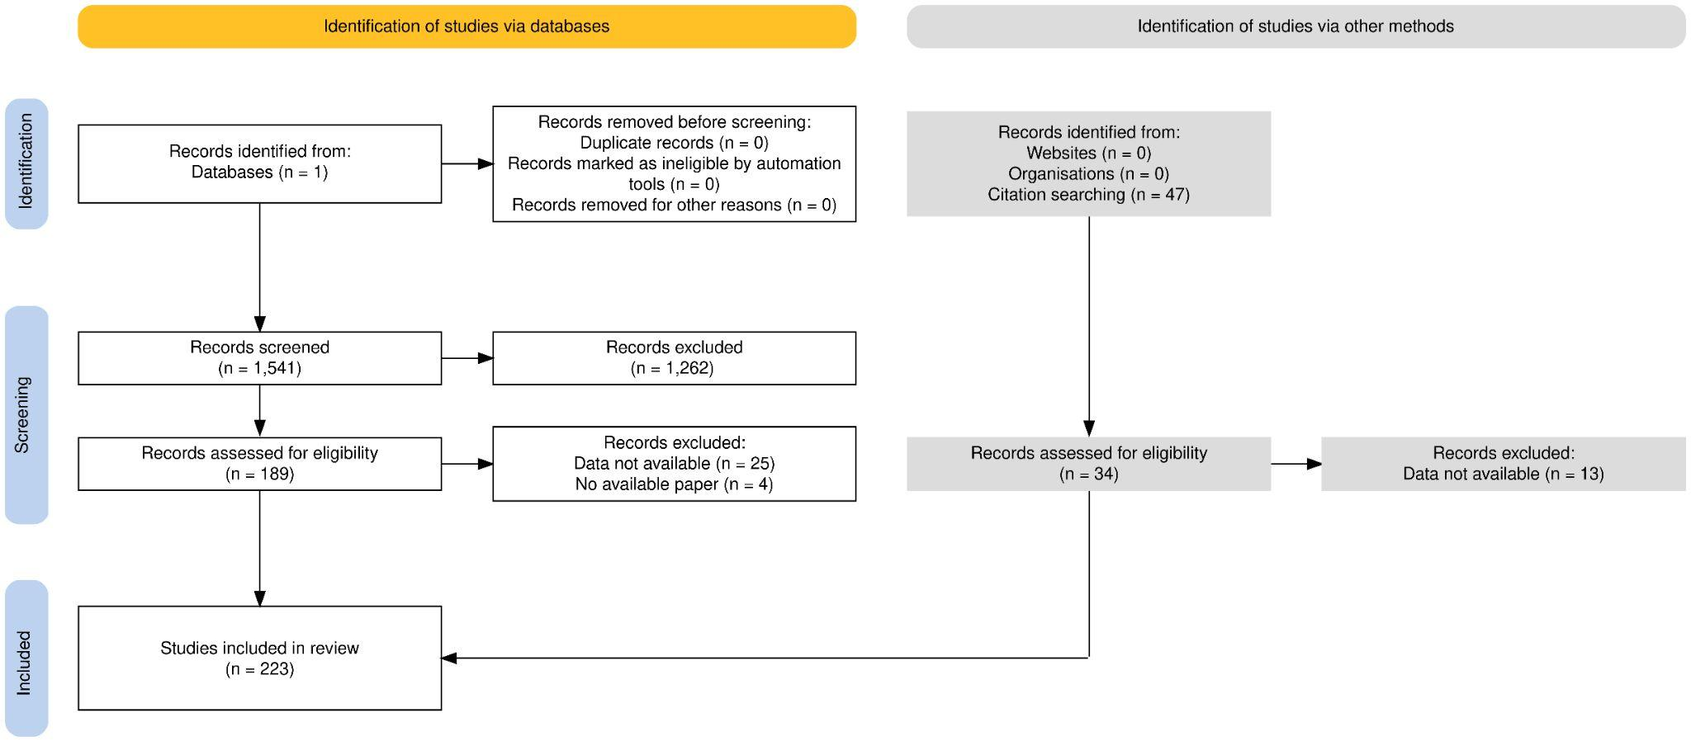

Figure S1. Preferred Reporting Items for Systematic Reviews and Meta-Analyses (PRISMA) diagram depicting the flow of information through the different phases of the systematic literature review. The diagram was created with the online resource PRISMA Flow Diagram (Haddaway et al., 2022).

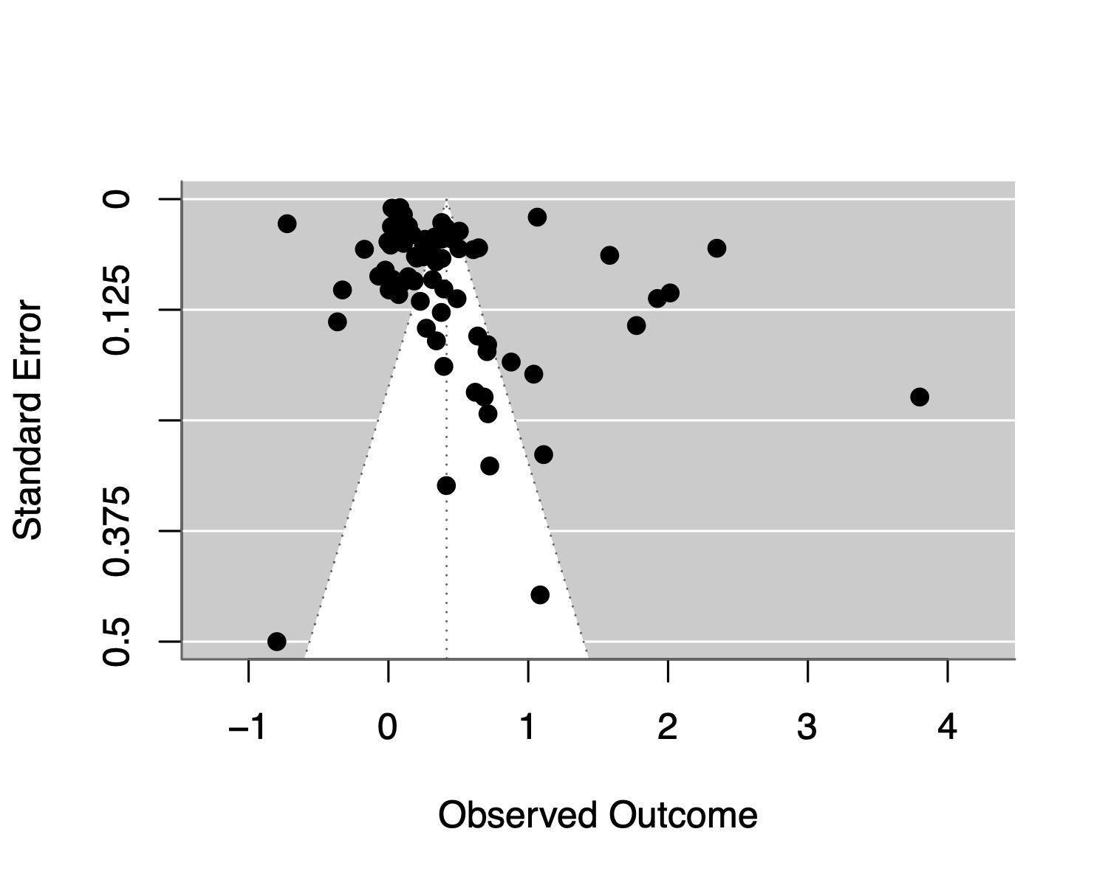
Figure S2. Funnel plot of study-level aggregated effect sizes (one estimate per study) showing effect size as a function of standard error. Larger, more precise studies cluster around moderate effect sizes, whereas smaller studies show greater variability and more extreme positive estimates, consistent with small-study effects.
Supporting literature

Haddaway, N. R., Page, M. J., Pritchard, C. C., & McGuinness, L. A. (2022). PRISMA2020: An R package and Shiny app for producing PRISMA 2020-compliant flow diagrams, with interactivity for optimised digital transparency and Open Synthesis Campbell Systematic Reviews, 18, e1230.

